**ASSIGNMENT-4**

|  |
| --- |
| DATE 28 October 2022 |
| Team ID PNT2022TMID49592 |
| Project Name Project-Personal Expense Tracker Application |
| Team Member Name Sabana Fathima S |

**1.Create a Bucket in IBM object storage.**

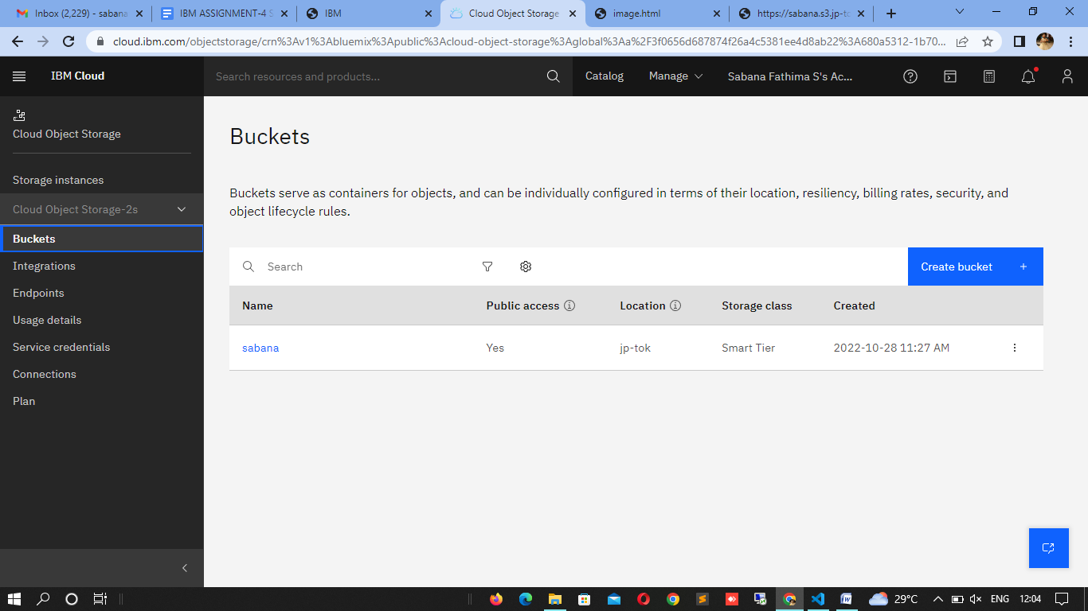

**2.Upload 5 images to ibm object storage and make it public. write html code to**

**displaying all the 5 images.**

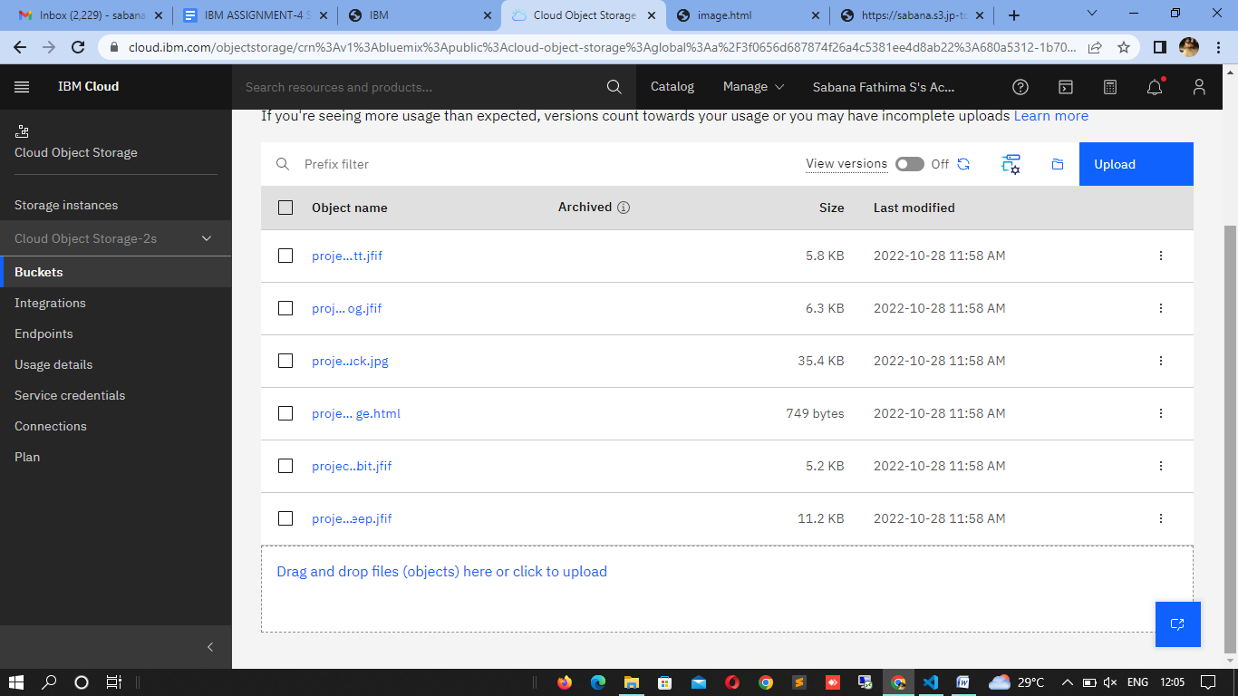

**image.html**

<!DOCTYPE html>

<html>

<head>

<style>

* {

box-sizing: border-box;

}

.column {

float: left;

width: 33.33%;

padding: 5px;

}

/* Clearfix (clear floats) */

.row::after {

content: "";

clear: both;

display: table;

}

</style>

</head>

<body>

<h2><CENTER>5 IMAGES</CENTER></h2>

<div class="row">

<div class="column">

<img src="catt.jfif" alt="Cat" style="width:60%">

</div>

<div class="column">

<img src="dog.jfif" alt="Dog" style="width:70%">

</div>

<div class="column">

<img src="duck.jpg" alt="Duck" style="width:100%">

</div>

<div class="column">

<img src="rabbit.jfif" alt="Rabbit" style="width:70%">

</div>

<div class="column">

<img src="sheep.jfif" alt="sheep" style="width:80%">

</div>

</div>

</body>

</html>

**3.Upload a css page to the object storage and use the same page in your HTML code.**

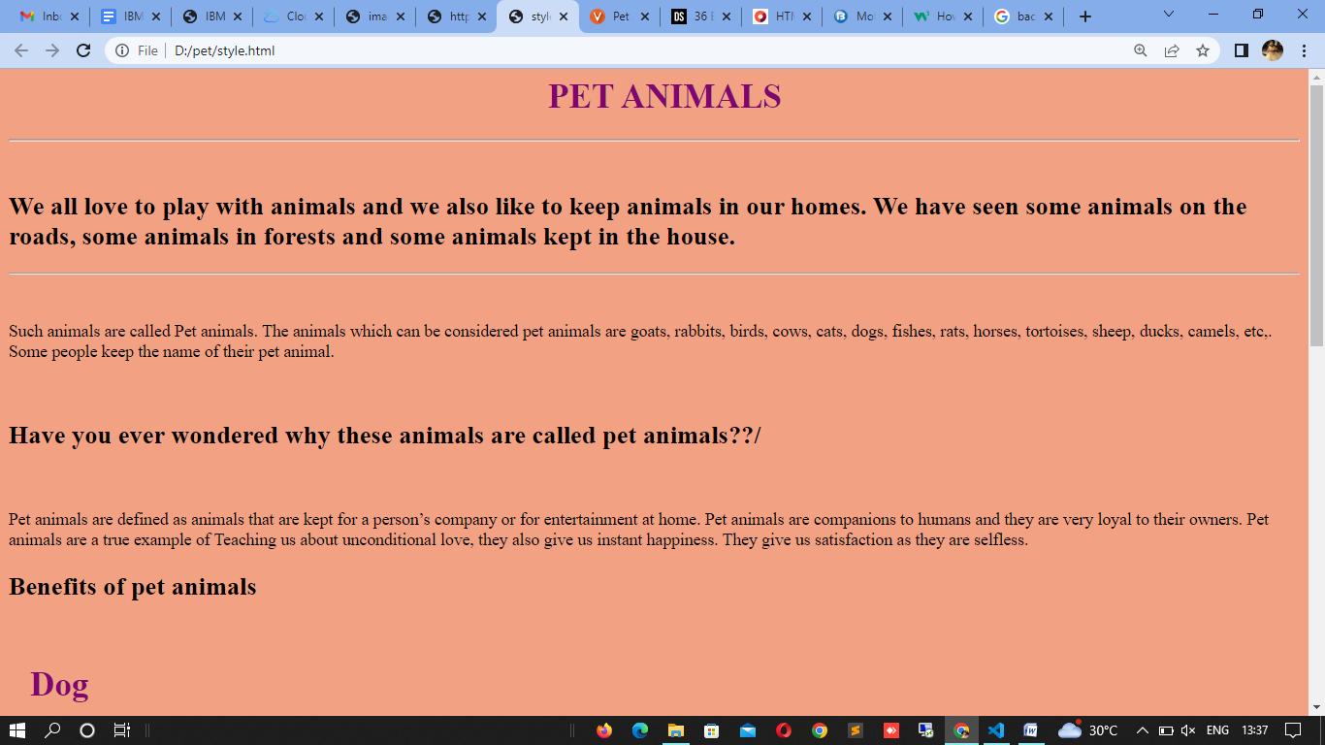

**Style.html:**

<html>

<head>

<link rel="stylesheet" href="external.css">

</head>

<body>

<h1><center>PET ANIMALS</center></h1>

<HR><BR>

<h2>We all love to play with animals and we also like to keep animals in our homes. We have seen some animals on the roads, some animals in forests and some animals kept in the house. </h2>

<hr><br>

<p> Such animals are called Pet animals. The animals which can be considered pet animals are goats, rabbits, birds, cows, cats, dogs, fishes, rats, horses, tortoises, sheep, ducks, camels, etc,. Some people keep the name of their pet animal. </p>

<br>

<h2><b>Have you ever wondered why these animals are called pet animals??/</b></h2>

<br>

<p>Pet animals are defined as animals that are kept for a person’s company or for entertainment at home. Pet animals are companions to humans and they are very loyal to their owners. Pet animals are a true example of Teaching us about unconditional love, they also give us instant happiness. They give us satisfaction as they are selfless.</p>

<h2>Benefits of pet animals</h2><br>

<h1>Dog</h1><br>

<p>Dogs are the most lovable pets which people like to keep in their homes. Dogs are good companions to humans as they are available in different species. People like to keep different dogs in their homes and people also give lovable names to the dogs.</p>

<br>

<h1>Cat</h1><br>

<p>D Cats are very adorable and can easily blend in well with their family members, they are very fluffy in nature as they are very soft like sponges and people love to cuddle cats by keeping them as pets.</p>

<br>

<h1>Rabbit</h1><br>

<p> people like to keep rabbits in cages in their homes. A rabbit can live for 8 to 12 years and also can be trained but they need more attention as compared to dogs and cats.</p>

<br>

<h1>Sheep</h1><br>

<p>Sheep are very friendly and they also have immense benefits to being kept as pets in the house.</p>

<br>

<h1>Duck</h1><br>

<p> Keeping ducks as a pet is very beneficial as they give us eggs. So people love to keep ducks, so as to earn their livelihood.</p>

<br>

</body>

</html>

**External.css:**

body {

    background-color: #f3a183;

  }

  h1 {

    color: #800571 ;

    margin-left: 20px;

  }

**4.Design a chatbot using IBM Watson assistant for hospitals. Ex: User comes with a query to know the branches for that hospital in your city. Submit the web URL of that chat bot as an assignment.**

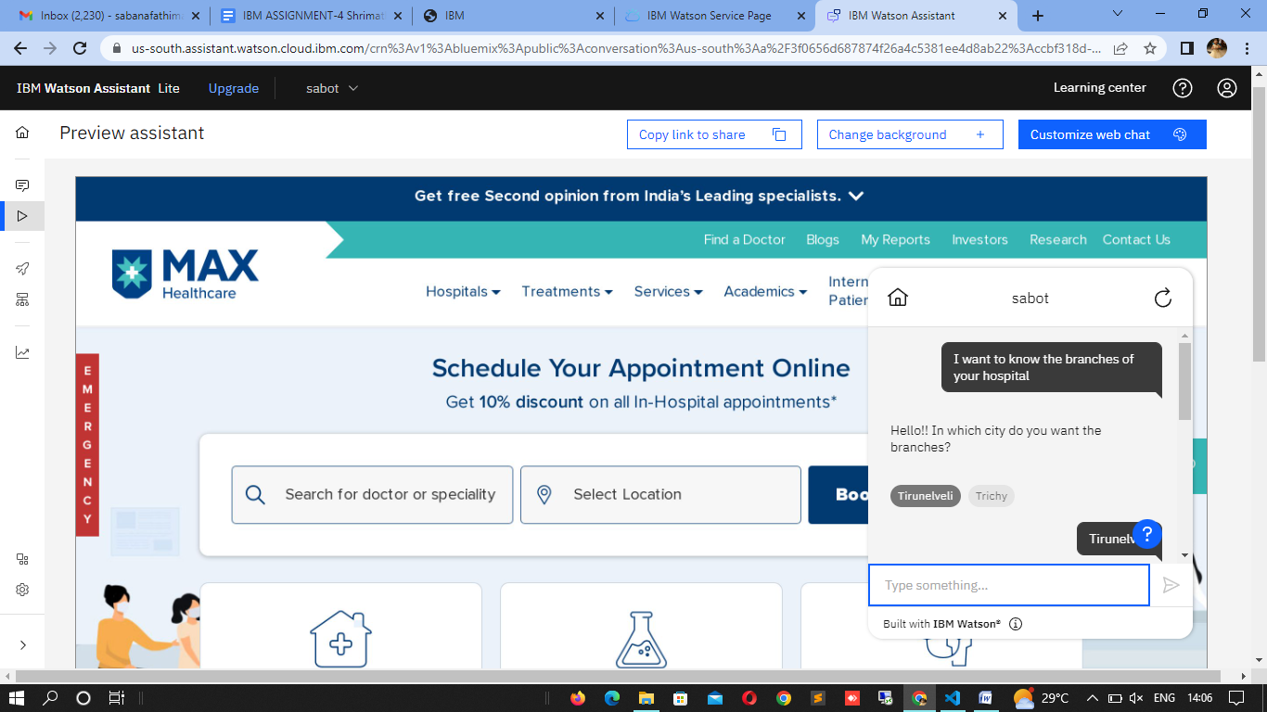

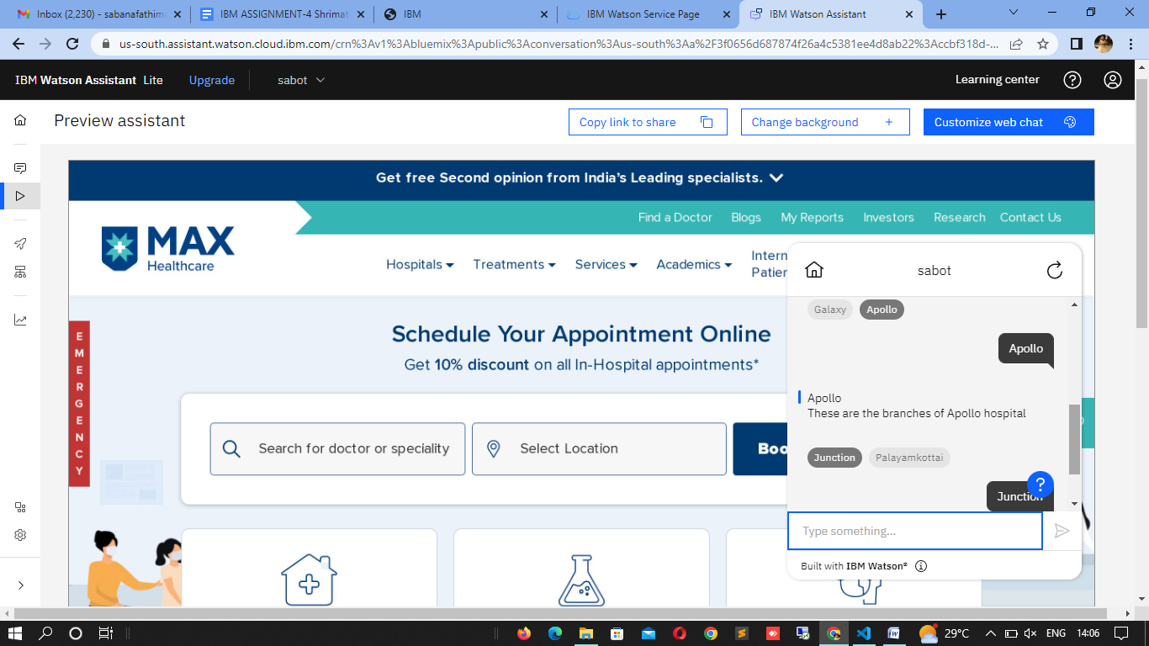

Web URL:

<https://webchat.global.assistant.watson.appdomain.cloud/preview.html?backgroundImageURL=https%3A%2F%2Fus-south.assistant.watson.cloud.ibm.com%2Fpublic%2Fimages%2Fupx-ccbf318d-d38b-4456-9052-70a93ef5edd3%3A%3A57f009b8-d22f-4b08-993e-37d4fac01529&integrationID=24490e60-700b-4bca-b82b-9164c8f7ab6a&region=us-south&serviceInstanceID=ccbf318d-d38b-4456-9052-70a93ef5edd3>

**5.Create Watson assistant service with 10 steps and use 3 conditions in it. Load that script in the HTML page.**

**Image.html**

<!DOCTYPE html>

<html>

<head>

<style>

* {

box-sizing: border-box;

}

.column {

float: left;

width: 33.33%;

padding: 5px;

}

/* Clearfix (clear floats) */

.row::after {

content: "";

clear: both;

display: table;

}

</style>

</head>

<body>

<h2><CENTER>5 IMAGES</CENTER></h2>

<div class="row">

<div class="column">

<img src="catt.jfif" alt="Cat" style="width:60%">

</div>

<div class="column">

<img src="dog.jfif" alt="Dog" style="width:70%">

</div>

<div class="column">

<img src="duck.jpg" alt="Duck" style="width:100%">

</div>

<div class="column">

<img src="rabbit.jfif" alt="Rabbit" style="width:70%">

</div>

<div class="column">

<img src="sheep.jfif" alt="sheep" style="width:80%">

</div>

</div>

<script>

  window.watsonAssistantChatOptions = {

    integrationID: "0b8623f9-9e04-4d22-9ddb-d4d780fb0b35", // The ID of this integration.

    region: "us-south", // The region your integration is hosted in.

    serviceInstanceID: "ccbf318d-d38b-4456-9052-70a93ef5edd3", // The ID of your service instance.

    onLoad: function(instance) { instance.render(); }

  };

  setTimeout(function(){

    const t=document.createElement('script');

    t.src="https://web-chat.global.assistant.watson.appdomain.cloud/versions/" + (window.watsonAssistantChatOptions.clientVersion || 'latest') + "/WatsonAssistantChatEntry.js";

    document.head.appendChild(t);

  });

</script>

</body>

</html>

Output:

